
Lesson 15 Teacher's Key: Ready to Show
001 Game Creator (Windows only) - Instructor Reference Only
VIDEO GAME CREATION

How This Key Is Different Today
There's no new Level 1 solution to give this week - Lesson 15 is a polish-and-present day, not a new-mechanic day. This Key instead consolidates the most common last-mile issues seen across this engine's Lessons 2-14, to help you diagnose a stuck student quickly during polish time.
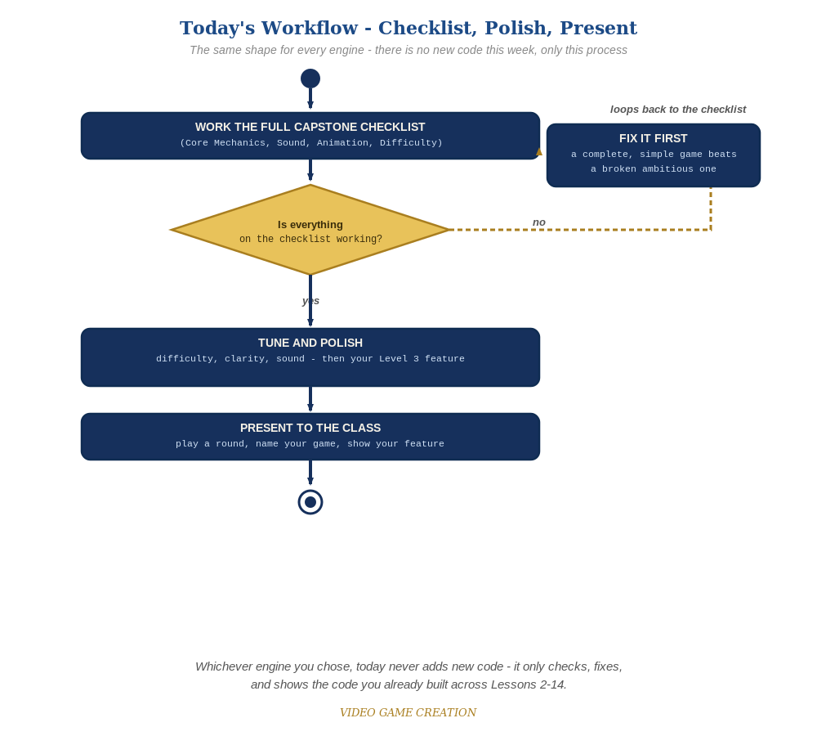
Today never adds new code - the same checklist-polish-present loop applies no matter which engine you chose.

Known Recurring Quirks in This Engine
- An Actor name typo (enemy_6 vs Enemy_6, for example) silently breaking a Custom Event's reference to it, with no obvious error shown.
- A Trigger missing the If(game_active = 1) gate from Lesson 10, allowing score/lives/wave to keep changing after the round has already ended.
- A pre-placed Actor left in the wrong starting position after manual testing/dragging in the editor, so it teleports incorrectly on the next SpawnWave.

Fast Diagnostic Questions
- "Does this Actor's name match EXACTLY, including capitalization, everywhere it's referenced?" - the most common root cause of a silently-broken Custom Event.
- "Is this Trigger's logic wrapped in If(game_active = 1)?" - relevant anywhere score/lives/wave could still be changing after a win or loss.

If a Student Is Significantly Behind
Prioritize getting Lessons 6-11's Level 1 (win/lose, restart, multiple waves) solidly working before anything from Lessons 12-14 - a complete, simple game presents better than a broken ambitious one.

Presentation Day Notes
- Have students Save and reopen the project before presenting if anything felt unstable during testing, since this engine benefits from a clean reload more than most.

